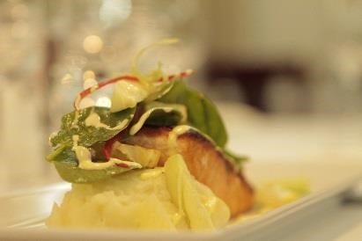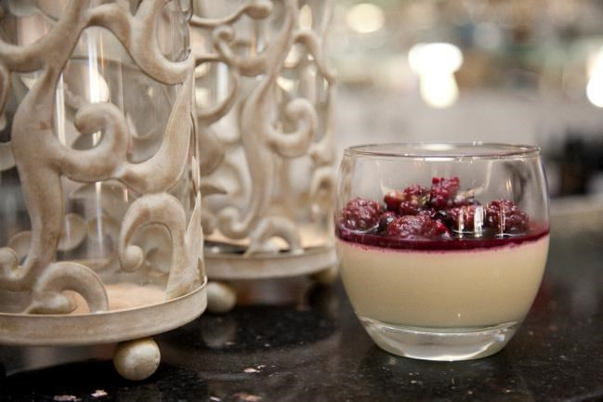

Group Dinners
-Please select 2 choices per course to be served alternate
Three Course $45
Two Course $39

Entrée served alternate

Hot options
*Pumpkin ravioli served with a creamy sauce
*Chicken satay skewers accompanied with rice and a creamy satay sauce
*Confit pork belly served with rice and caramelised apple wedges
*Bite sized chicken fajitas served with avocado salsa
*Creamy garlic prawns served on a bed of fragrant rice
*Creamy pumpkin soup served with ciabatta bread

Cold options

*Turkey and avocado stack
*Chicken Caesar salad, mixed lettuce, bacon, parmesan cheese and freshly
baked croutons served with a homemade Caesar dressing
*Thai beef salad. Marinated in a ginger, garlic, chilli and fresh coriander, served with mixed lettuce, crunchy noodles and a cucumber mint Tzatziki
*Prawn salad, mixed lettuce served on a crunchy noodle nest
*Vegetarian frittata

Mains served alternatively

*250gram porterhouse steak served with potato Rosti, seasoned vegetables and red Wine jus
*Miso barramundi served with Asian greens on a creamy garlic and shallot mash
*Slow braised Lamb shank in a rosemary and stout sauce rested upon a creamy mashed potato.
*Chicken breast wrapped in prosciutto served with sweet potato mash and string beans with a chicken Beurre Blanc
*Vegetable lasagne served with a sweet potato couscous
*Potato gnocchi served with a tomato pasta sauce which has been seasoned to perfection
*Chicken breast filled with pine nuts, pesto and cheese served with garlic mash and seasonal vegetables
*Beef wellington served with potato Rosti, seasonal vegetables and a red wine jus
*Salmon broiled seasoned with breadcrumbs, garlic, lemon and butter served with a crunchy potato Rosti, Bok Choy finished in a lemon dill cream sauce
*Pork cutlet served with seasonal vegetables and apple sauce

Dessert served alternatively

*Poached pears, full pears that have been slowly poached in red wine and served with vanilla bean ice cream
*Sticky date pudding served with butterscotch sauce and ice cream
*Chocolate Brownie with Tim Tam ice cream
*Individual Pavlovas served with fresh double cream and seasonal berries
*Midori Pannacotta with a citrus and berry syrup
*Lemon vanilla cheesecake served with ice cream
*Chocolate mousse served with fresh seasonal

OR

